This colorful salad is as easy to make as it sounds. Marinade zucchini, sun dried tomatoes, olives, and peppers for 1-2 hours in balsamic vinegar & spices or your dressing of choice . When ready to serve, toss with your favorite variety of greens.
Zucchini Sun Dried Tomato, Olive, Capsicum (Peppers) & Chopped Salad

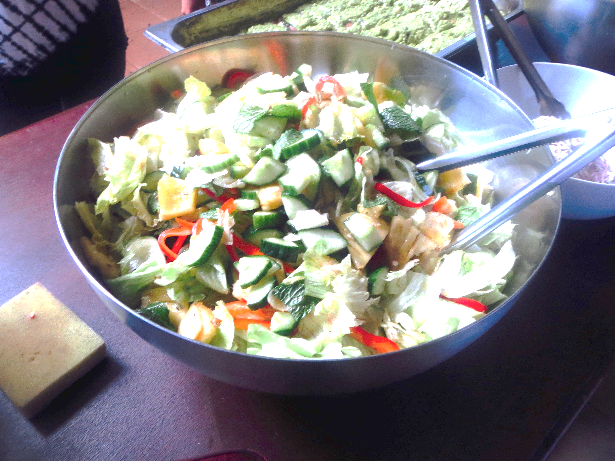
Mix quantities and proportions to suit your taste! There’s always room for creativity. Feel free to add other fresh vegetables, nuts, onion, garlic, curry and other flavors…

Make with or without greens.
